**January 29, 2018**

EECE 6038C: Advanced Microsystem Design

Instructor: Purva Bhatnagar

Voice/Web Home Monitoring and Alarm System

University Of Cincinnati

Project Proposal

Sall, Djibril (salldl)

SPRING2018

Table of Contents

I. Objectives: 1

II. Technical Approach: 2

1) Hardware: 2

a) Sensors: 2

b) Actuators: 2

c) Mikromedia Board: 2

d) Node MCU: 3

2) Software: 3

a) Firmware: 3

b) Node Red: 4

c) Mosquito Server: 4

d) Google Assistant, IFTT and adafruit.io: 4

3) Diagrams: 5

III. Project Management: 5

1) Team: 5

2) Tentative of Schedule and Gant Chart: 6

IV. Conclusion: 7

# Objectives:

The goal of this project is to build a home monitoring and alarm system that will be able to provide real time information via a web app as well as the ability to control actuators in the house using voice. This can help one get real time information about the temperature in a given room or the house as well as turn off some appliance from distance without the need of being there. We will build first a system that controls lights in the house as well as sensors that can give information about a detection of fire, light, or smoke inside the house.

Using their mobile phone the person can see a detailed view of the information about the house anywhere in the world as long as they have an internet connection to connect to the web app. We also going to add voice control to the system, so that the owner can issue commands just using their voice, without the need of having to go to the web app. Adding the voice functionality can also help people with sight disabilities to issue commands and get audio feedbacks.

# Technical Approach:

In order to make this project work we are going to use to microcontrollers the Mikromedia board with the pic24 and the Node MCU board with the esp8266 chip, as well as several sensors for the hardware side of things.

For the software, we will be using a Ubuntu server running on the amazon EC2 instance running a node-red server and a mosquito server for the web interface.

We will also use Google Assistant, IFTT and adafruit’s MQTT services for the voice control.

## Hardware:

### Sensors:

We will have a temperature sensor, flame detector, smoke detector, motion sensor and some switches that will act as door and windows sensor just to simulate some events.



### Actuators:

We will have some LED’s to show the status of the alarm, but also some buzzers or a speaker connected to the mikromedia board to give some audio feedbacks in the house.

### Mikromedia Board:

The mikromedia will be our main computer as it will not only act as a userinterface inside the house but it will also act as the main computer that handles all the physical IO’s. we will be also using the TFT screen on the micromedia board to show the status of our system.

It will analyze the states of the sensors or input been issued to it in order to change the states of the different IO’s. Given that the mikromedia board don’t have a wifi shield, we will be using the node MCU as a bridge between the mikromedia board and our web applications.

 

### Node MCU:

The node MCU is a small microcontroller which contains an esp8266 which is a wifi chip that supports MQTT. It will be getting inputs from the mikromedia board and transport it to our webserver using MQTT protocol. It will also get inputs from our web app and voice control app and send them to the mikromedia. In case of a problem with our internet connection our web app will sense it from the Node MCU and send us an email as well as give us show us visually in the app that our system is not working properly.



## Software:

### Firmware:

We will write firmware for both the pic24 and the esp8266 in order to operate with our webserver and sensors properly.

### Node Red:

The node red server will be running in our Ubuntu server and it will provide the user with a dashboard that shows the status of the house but can also help us control our system. It will communicate with the mikromedia board with the Help of the node MCU board via MQTT.



### Mosquito Server:

The mosquito server will be our MQTT server running on the Ubuntu instance.

MQTT is an ISO standard publish-subscribe-based messaging protocol; It works on top of the TCP/IP protocol. It will help our Node MCU to publish information received from the Mikromedia board to our webserver. On the other hand the Node MCU will also subscribe to topics generated from the node red server and send our inputs to the mikromedia board.

### Google Assistant, IFTT and adafruit.io:

This part is the part handling our voice interaction with the system. One can use their phone or wearable smartwatch and issue commands that will be sent to our adafruit.io, which will send it to the Node MCU which will pass those information to the mikromedia board.

For example, a person will be able to use their phone or watch or any google assistant device to say “OK Google, arm the system” and it will arm the home alarm system. This makes interaction easier and faster.

## Diagrams:



# Project Management:

## Team:

I’m working on the project alone. Given that I worked before in some small parts of this project like the node server and MQTT as well as Google Assistant, I will just have to integrate all my knowledge together.

## Tentative of Schedule and Gant Chart:

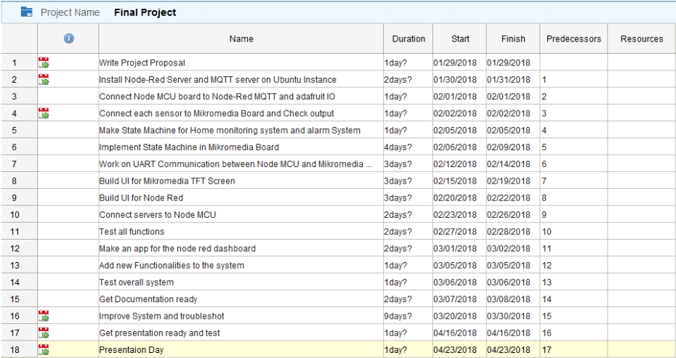

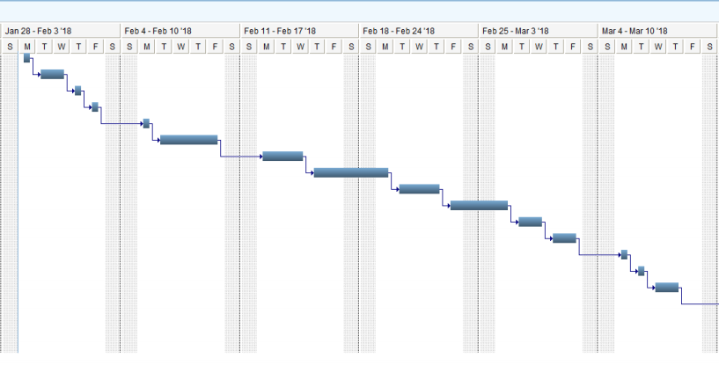

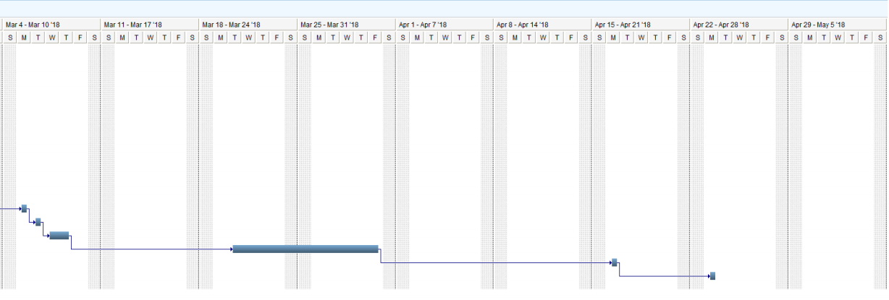

1. Budget:

|  |  |  |
| --- | --- | --- |
| Project Budget | | |
| Quantity | Component | Price |
| 1 | Mikromedia PIC24 | $99.00 |
| 1 | Node MCU | $6.00 |
| 10 | Sensors and LEDs | $10.00 |
| 1 | Amazon EC2 Server | $- |
|  | Softwares (Open Source) | $- |
| Total | | $115.00 |

# Conclusion:

This project will help us not only use all the functionalities and features included in the mikromedia board. It will also help us build an IOT system by interfacing the mikromedia board with a server.